Simulation Report: Structural Analysis of I-Beam
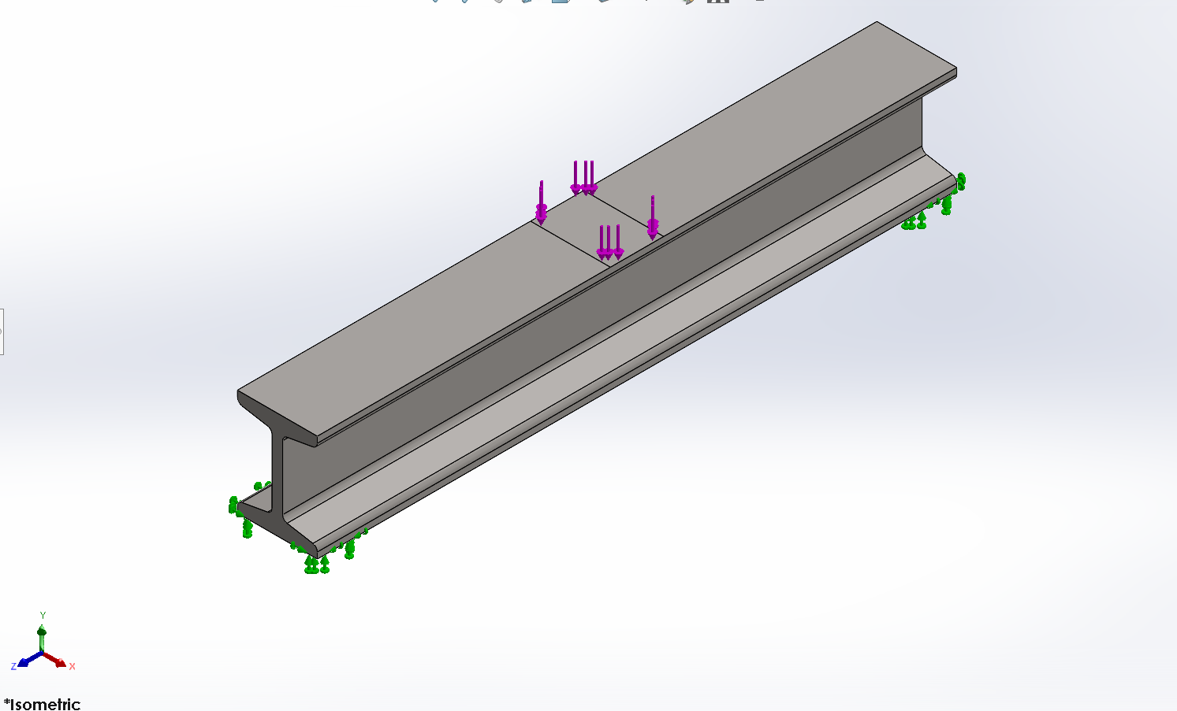

Table of Contents:
1. Study Information: 2
2. Model Description: 2
3. Material Properties (AISI 304): 2
4. Boundary Conditions: 3
5. Mesh Information: 4
6. Results and Discussion: 5
6.1 Von Mises Stress: 5
6.2 Strain: 6
6.3 Displacement: 7
6.4 Factor of Safety: 8
7. Result Summary: 8
8. Conclusion: 8
9. Further Improvements: 9
10. Appendix: 9

1. Study Information:
- Model Name: I Beam
- Study Name: Static 1 (Default)
- Software: SOLIDWORKS 2025
- Analysis Type: Linear Static
- Units: SI (N, m, MPa)

2. Model Description:
The model represents an I-beam subjected to multiple downward loads. One end is fixed, simulating a cantilever beam condition.
- Geometry: Solid I-section beam
- Material: AISI 304 Stainless Steel
- Support: Fixed at one end
- Loading: Concentrated forces on top flange

3. Material Properties (AISI 304):
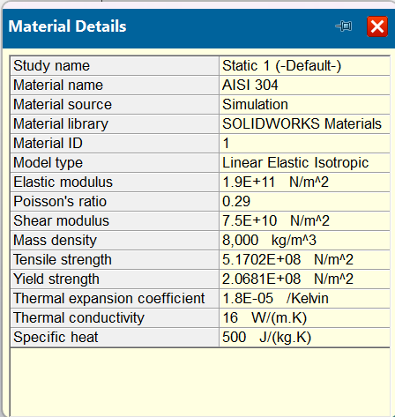
From your material window:
- Elastic Modulus: 1.9 × 10¹¹ N/m²
- Poisson’s Ratio: 0.29
- Shear Modulus: 7.5 × 10¹⁰ N/m²
- Density: 8000 kg/m³
- Tensile Strength: 517 MPa
- Yield Strength: 206.8 MPa
- Thermal Expansion: 1.8 × 10⁻⁵ /K
- Thermal Conductivity: 16 W/m·K
- Specific Heat: 500 J/kg·K
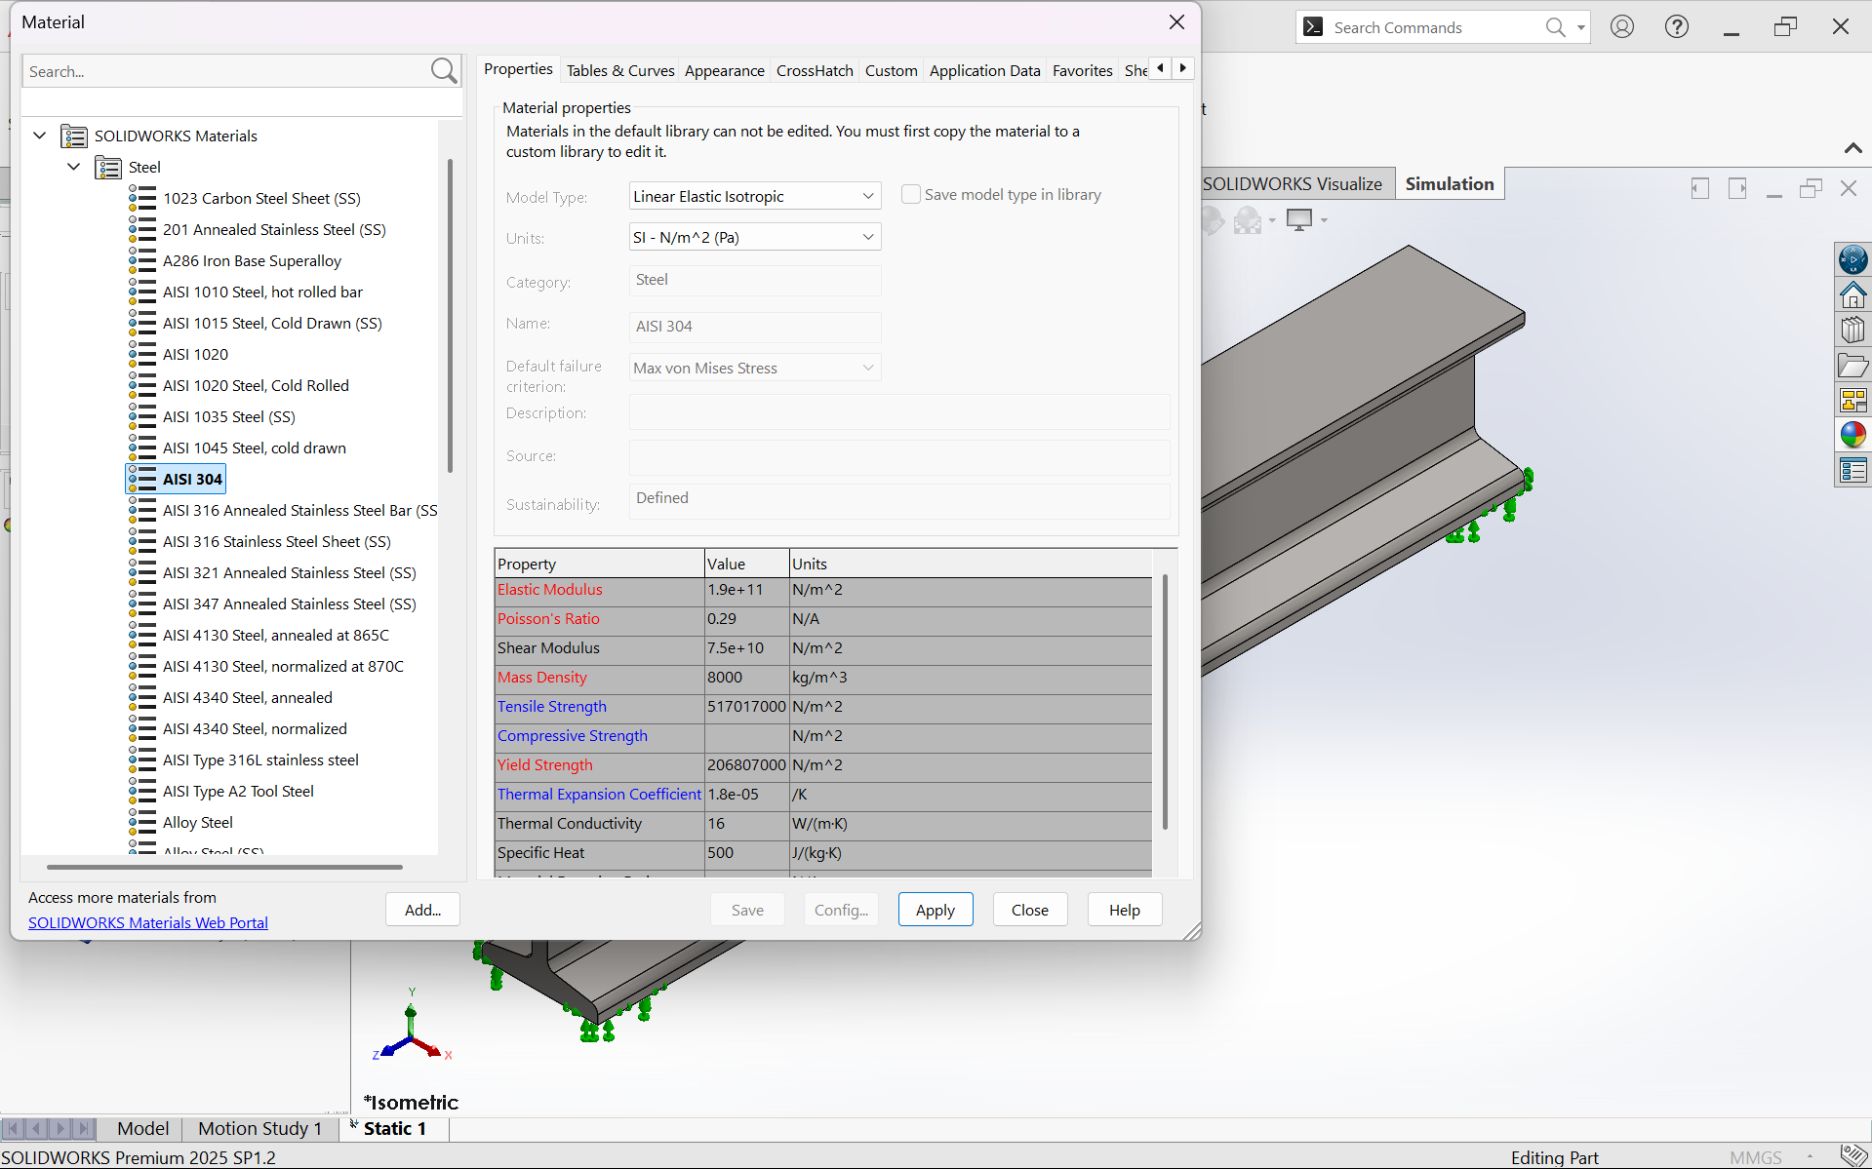

4. Boundary Conditions:
- Fixture: Fixed geometry at one end
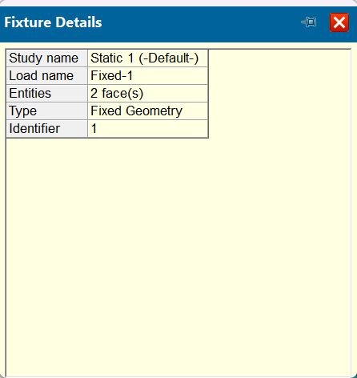
- Loads: Multiple vertical downward forces
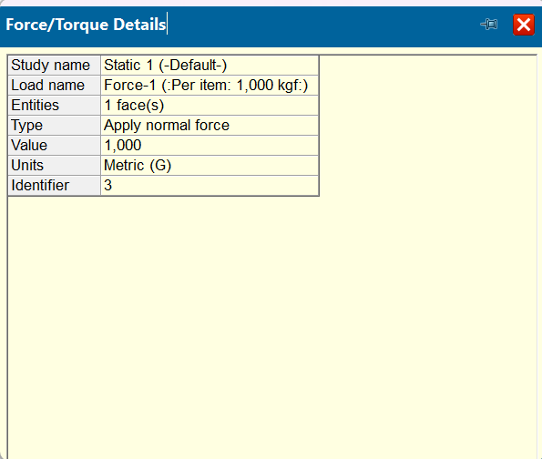
- Behavior: Cantilever bending

5. Mesh Information:
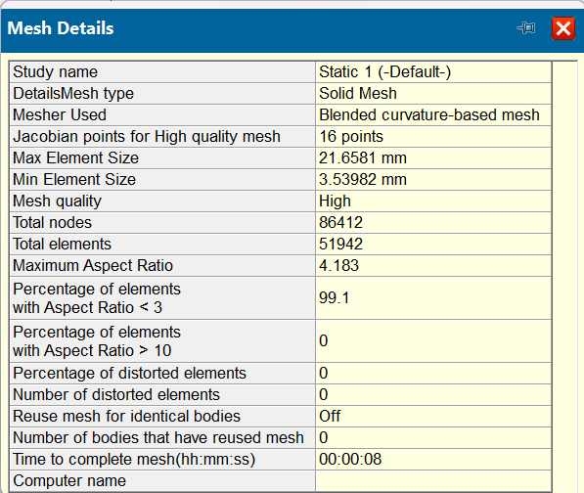
- Study name: Static 1 (-Default-)
- Mesh type: Solid Mesh
- Mesher Used: Blended curvature-based mesh
- Jacobian points for High quality mesh: 16 points
- Max Element Size: 21.6581 mm
- Min Element Size: 3.53982 mm
- Mesh quality: High
- Total nodes: 86412
- Total elements: 51942
- Maximum Aspect Ratio : 4.183
- Percentage of elements\with Aspect Ratio < 3 : 99.1
- Percentage of elements\with Aspect Ratio > 10 : 0
- Percentage of distorted elements : 0
- Number of distorted elements:0
- Reuse mesh for identical bodies: Off
- Number of bodies that have reused mesh:0
- Time to complete mesh(hh;mm;ss): 00:00:08

6. Results and Discussion:

6.1 Von Mises Stress:
- Maximum Stress: 31.2 MPa
- Minimum Stress: 2.543 × 10³ N/m²
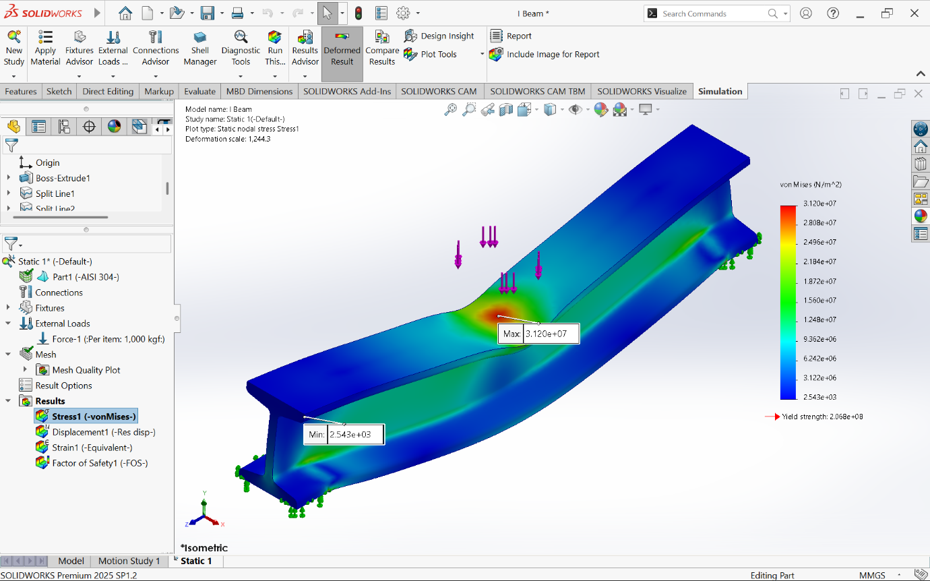
Interpretation:
- Maximum stress occurs near load concentration region
- Stress is much lower than yield strength (206.8 MPa)
Conclusion: Safe under given loading

6.2 Strain:
- Maximum Strain: 1.150 × 10⁻⁴
- Minimum Strain: 3.101 × 10⁻⁸
Strain distribution matches stress pattern, confirming elastic behavior.
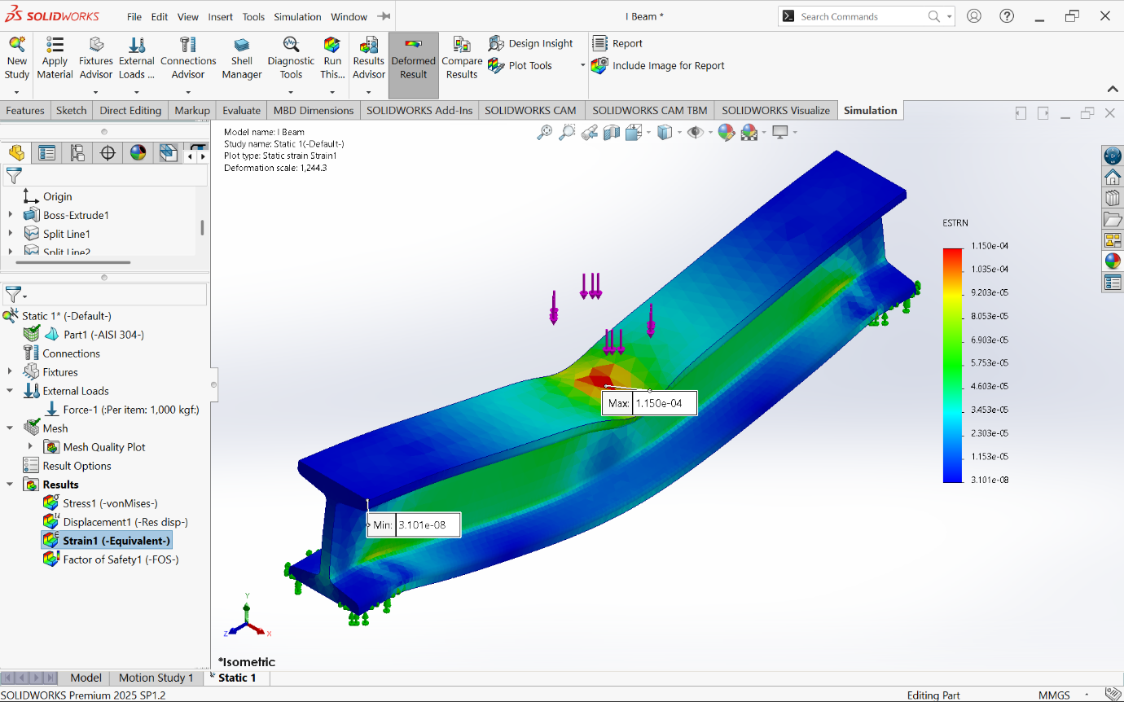

6.3 Displacement:
- Maximum Displacement: 0.04824 mm
- Minimum Displacement: ~0 mm
Maximum deflection occurs at the free end, typical of cantilever beams.
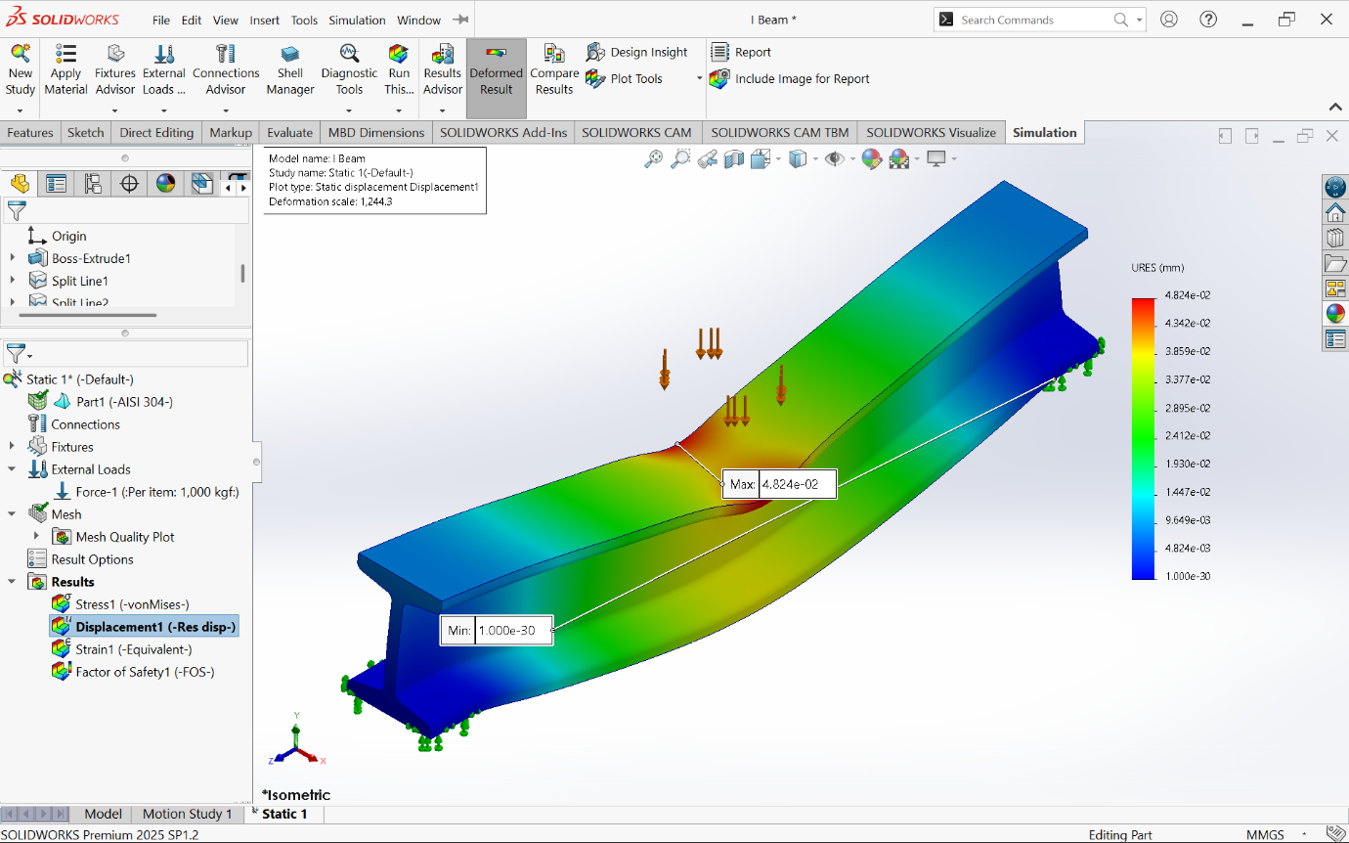

6.4 Factor of Safety:
- Minimum FOS: 6.628
- Maximum FOS: 8.131 × 10⁴
The structure has a very high safety margin, indicating conservative design.
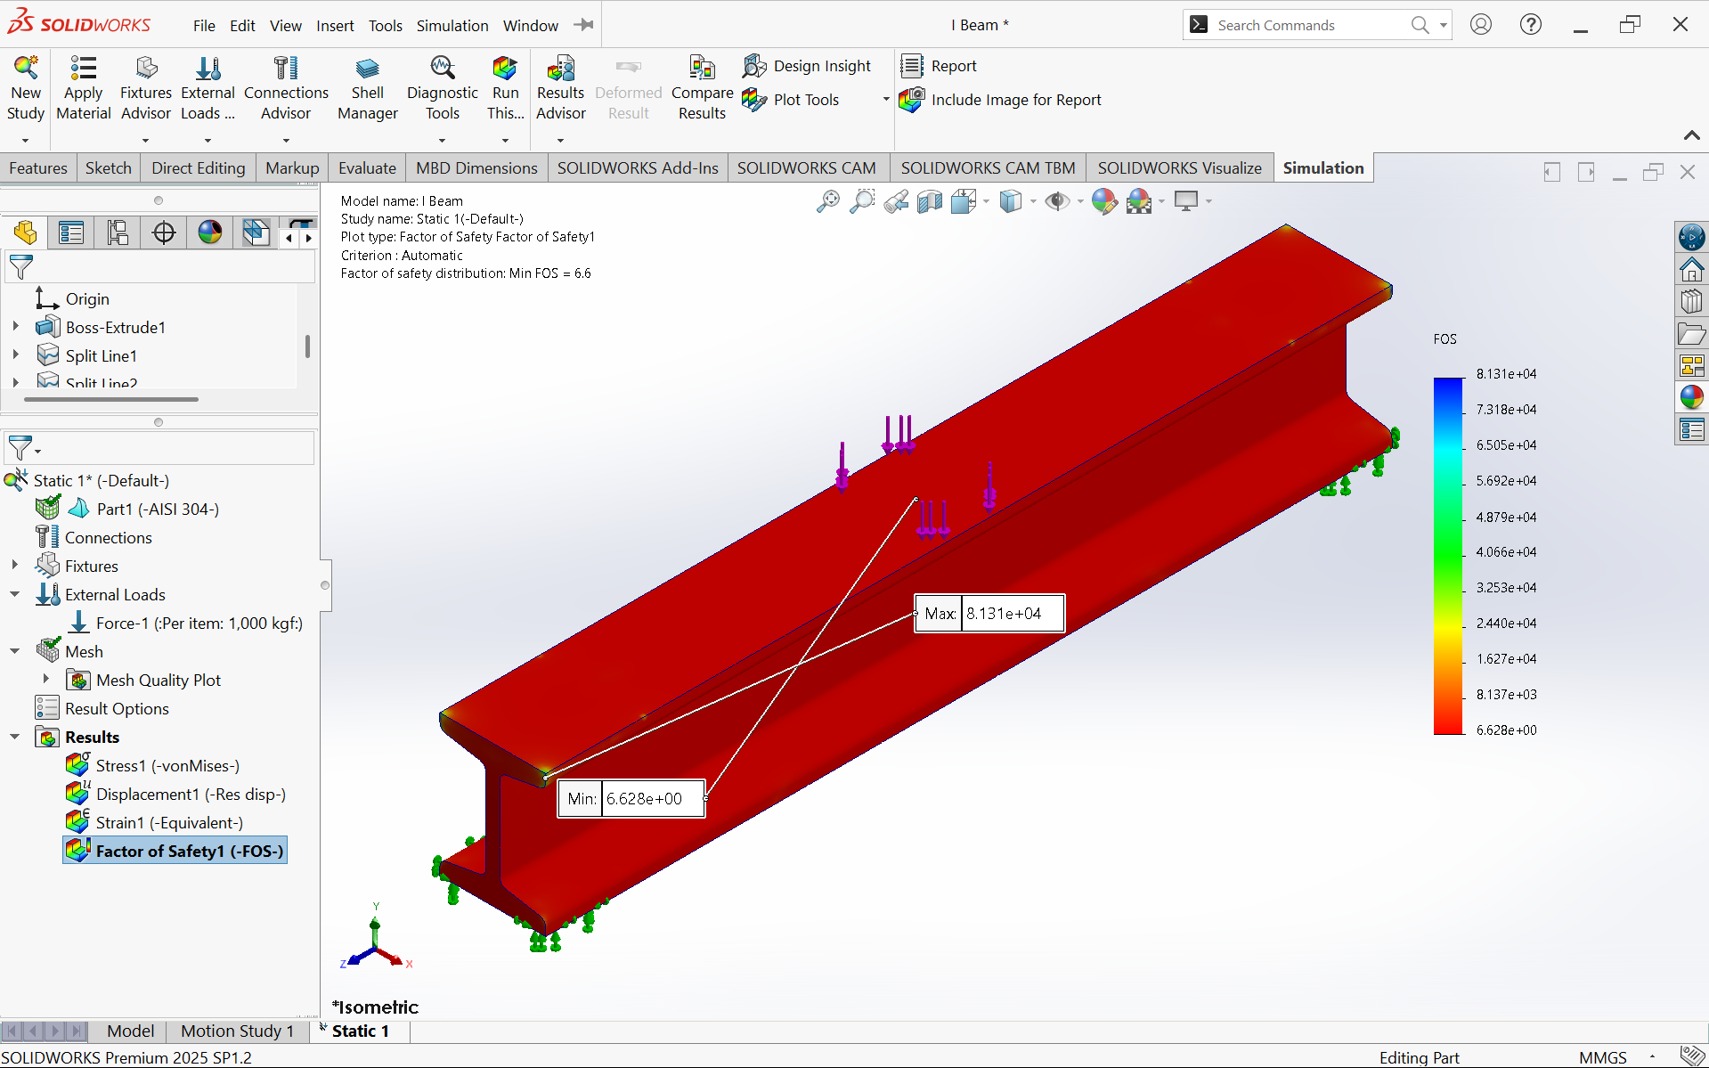

7. Result Summary:
- Stress << Yield Strength → No failure
- Very small deformation → High stiffness
- High FOS → Overdesigned but very safe

8. Conclusion:
The I-beam made of AISI 304 stainless steel performs safely under the applied loads. The stress, strain, and deformation values confirm that the structure remains within elastic limits and will not fail.

9. Further Improvements:
- Reduce material to optimize weight (since FOS is high)
- Try alternative materials for cost efficiency
- Perform fatigue analysis for cyclic loads
- Conduct buckling analysis for slender beams

10. Appendix:
- Stress contour (Von Mises)
- Strain plot
- Displacement plot
- Factor of Safety plot
- Material property table

